Purpose
This document outlines the procedures for receiving Crush It Welcome Kit merchandise into a single SKU within Reporting & Analytics (R&A).

Overview
Crush It merchandise will be arriving from (3) vendor partners and this product will be sold for $50 + tax from a unique SKU built within R&A. All (3) invoices will be received together into this ONE SKU to obtain a “cost per unit” combined price. Crush It Welcome Kit retail buttons have bee created within the MICROS POS for sales and these will remove a quantity of (1) of these units from the inventory platform for a fixed value of $50 + tax.

Procedures
- Obtain (2) Invoices from Ahead and GT Golf Supplies for the Crush It Welcome Kit backpack and cap. The third invoice for the binder will have the expense coded to your department by ClubCorp corporate. All three will be combined into a single wholesale cost value when received into Reporting & Analytics (R&A).
- Sign in to Reporting & Analytics using unique username and password.
- Click the “Inventory” button on the left-hand side of the screen, then click “Inventory” once it is populated below the original Inventory location.

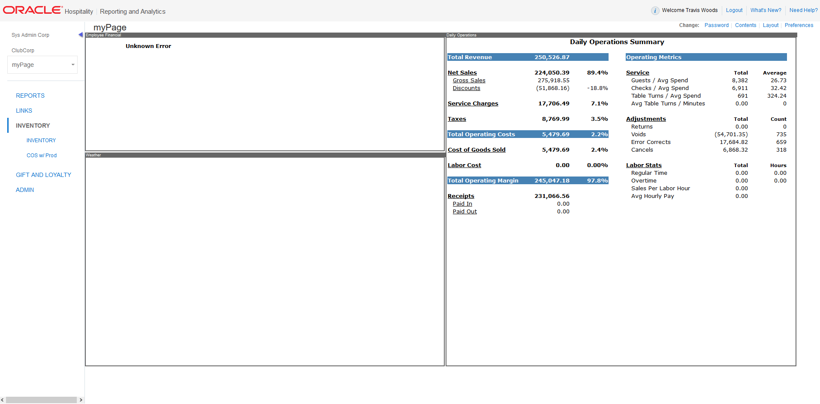

- Make sure the “Ordering” tab is selected, then click on “Receiving” from the below selection area.

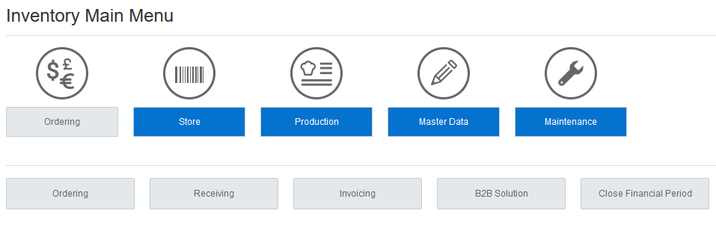
- Select “Vendor”
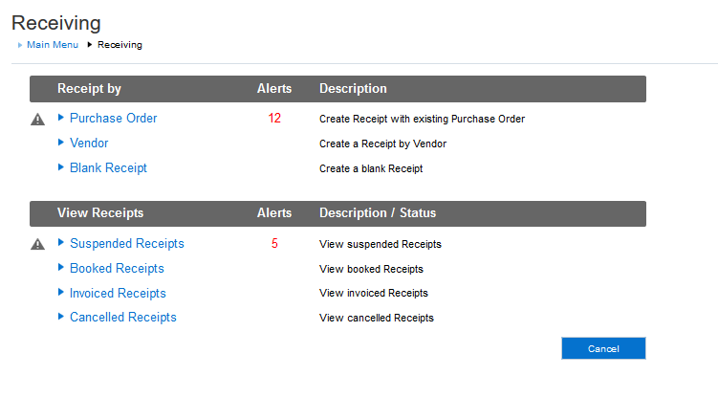
- Ensure your “Cost Center” is displayed prior to proceeding.
- Under the box that says “Vendor”, type in the vendor “Retail”. This is a unique vendor created for this receiving. Ensure you select the Vendor from the drop-down to pull in all information for this Vendor.
- In the “Receipt” box, type in “CRUSH IT PRODUCT”. Normally this is the invoice number, but this will cover this unique receiving of all three invoices.
- Delivery Date: THIS DATE MUST REMAIN THE DATE ON THE REPORT, DO NOT MODIFY! *This is the date you are receiving the items into inventory.
- In the “Reference” area, type in the (2) Invoices numbers:
Ahead - (review your invoice for this number)
GT Golf Supplies – (review your invoice for this number)
*The other two invoices will be charged to your club/department by ClubCorp Corporate.
This will reflect under GL#60103 COGS Expense for the department.
- You will then double click on “Retail Freight” form the Item Group Box. This will move “Retail Freight” into the right box.
NOTE: DO NOT SELECT A SPECIFIC ITEM GROUP AS THIS WILL ONLY DELAY YOUR RECEIVING PROCESS.
- Click “Create” at the bottom left-hand part of the screen.
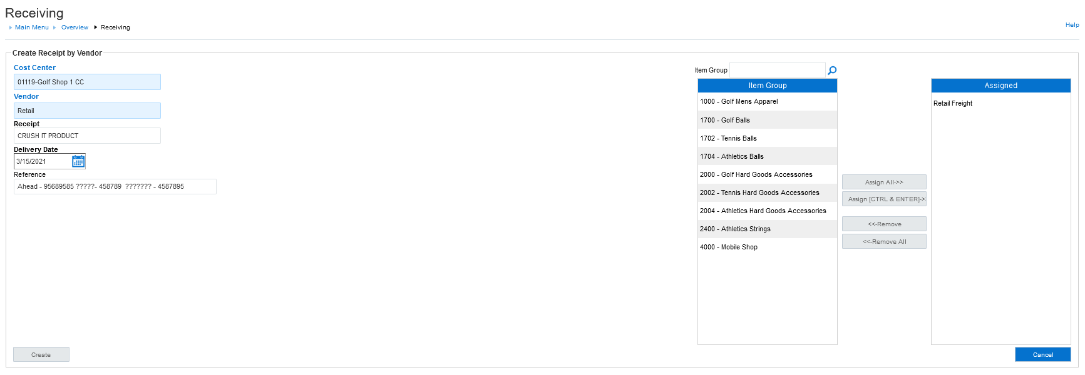

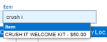
- Type “CRUSH IT WELCOME KIT $50” into the “Item” field to add this to the receiving report. NOTE: Make sure you “select” the items from the dropdown when they appear to pull into the receiving report.

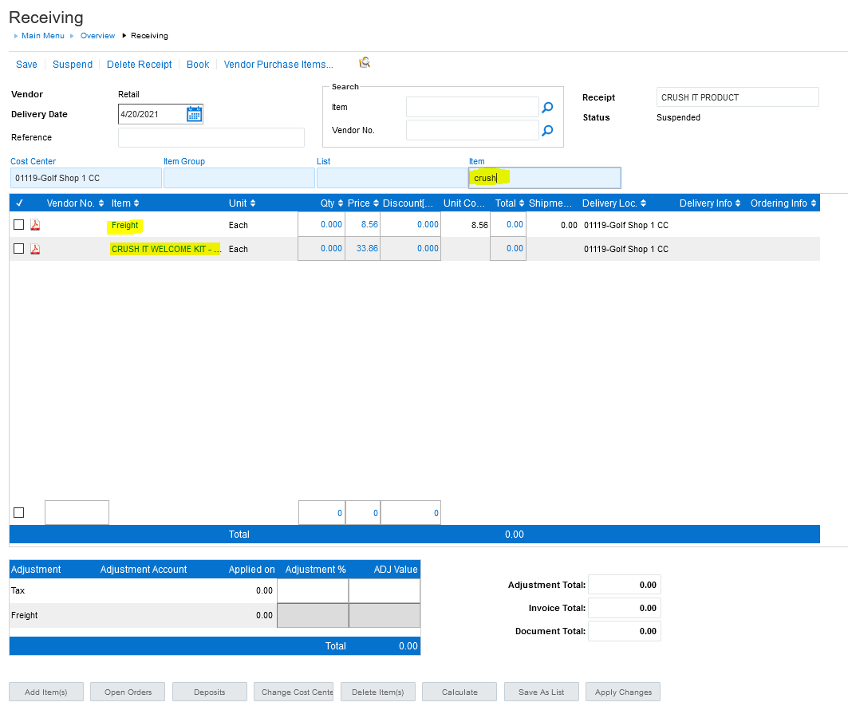

- Review both received Crush It Welcome Kit product invoices and obtain the “quantity” your received from both Ahead and GT Golf Supplies. These quantities should “MATCH”.
Example: If 18 units were received from each vendor on the invoice you would receive 18 units of the selected “Crush It Welcome Kit $50.00” SKU within the receiving report.
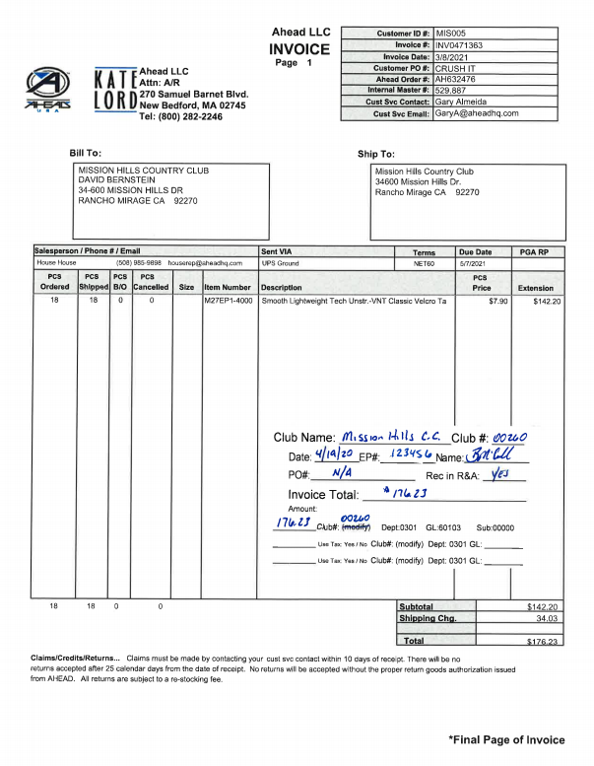
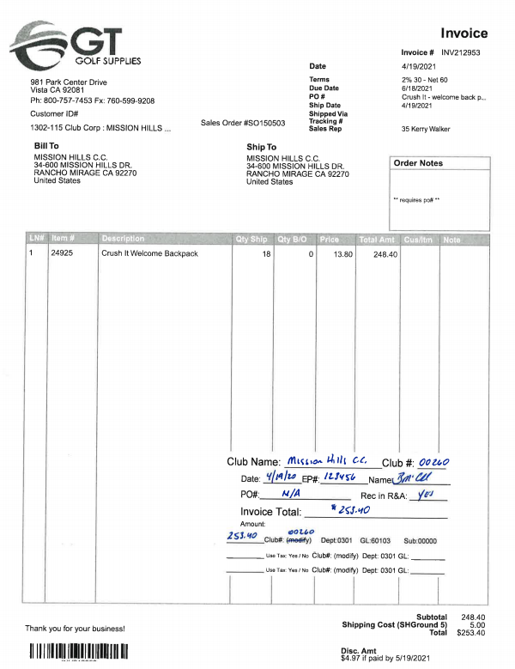

- Type in the total of all freight with a “quantity of 0” on the freight line. Also adjust the freight “cost” to be .01. With a “quantity of 0” freight will not be figured into the pricing. We will NOT be receiving a “stand-alone” freight line for this SKU.
- On the receiving line for the “Crush It Welcome Kit $50.00” SKU, after the quantity received, type in the ‘cost value” of $33.86 in the price field of the “Crush It Welcome Kit $50” SKU.
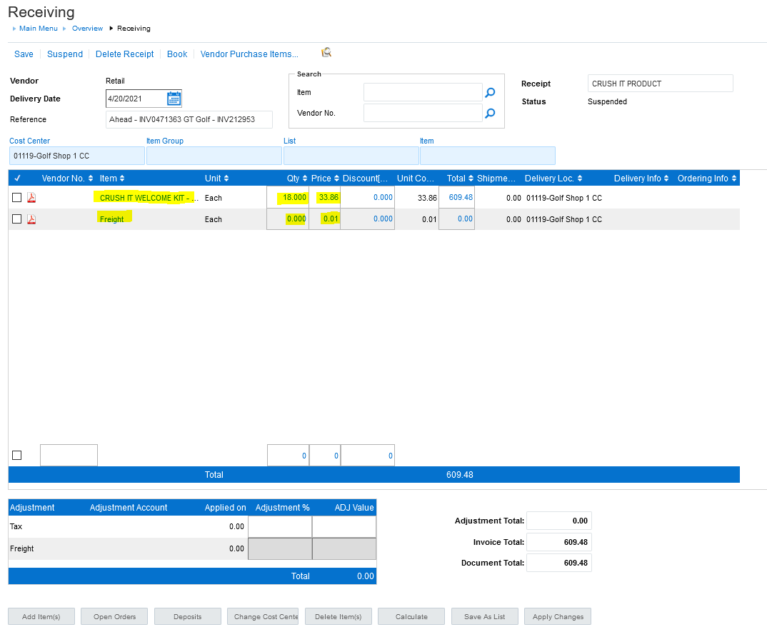

- Select the “Calculate” button at the bottom the screen which acts as a save button. The is will result in a calculation at the bottom of the receiving report.

This total will MATCH THE TOTAL OF ALL “FOUR” COMBINED INVOICES. (Invoices received and coded to 60103 COGS by the club for the Ahead and GT Golf Supplies, plus the other two invoices, folder and printing, that will be coded to the 60103 COGS of the department by ClubCorp Corporate.

This “cost value” will support a average COGS for the sale of the Crush It Welcome Kit to be approximately 68%.

- Once this TOTAL is Confirmed, select “Book” at the top of the screen.

- A pop up will appear and you will select the middle box that reads “Book Receipt as Invoice”, then select Ok.

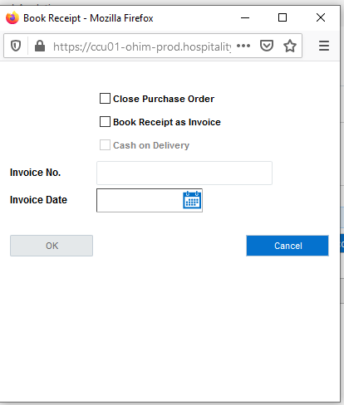

- The next pdf that appears will be what you print off and provide as back up for the receiving for the three invoices. To PRINT, select the printer ICON at the top right of the screen and this will print to your local network printer.

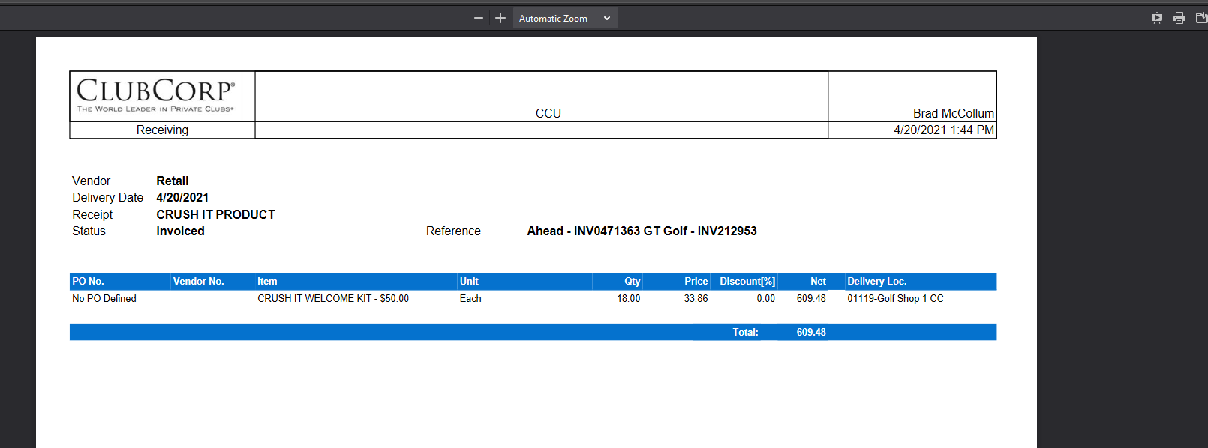

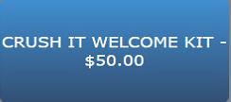
- For sales to all Crush It participants, a unique SKU has been quick keyed to your MICROS POS System. Select the “Merchandise” tab at the top, small blue tab “Quick Keys (Golf) on the right and use the “CRUSH IT WELCOME KIT $50.00” for all sales.

Use this for all sales as this is a “fixed” value button and will tie to the stock on hand created for this SKU. Note: Labels DO NOT need to be printed for these Welcome Kits.

