


Last Chance to Register for Our PGA Family Cup!

Final call for family fun! This is your last chance to register for our PGA Family Cup event(s) on dates at time.

Click here to register your family team: link to your registration

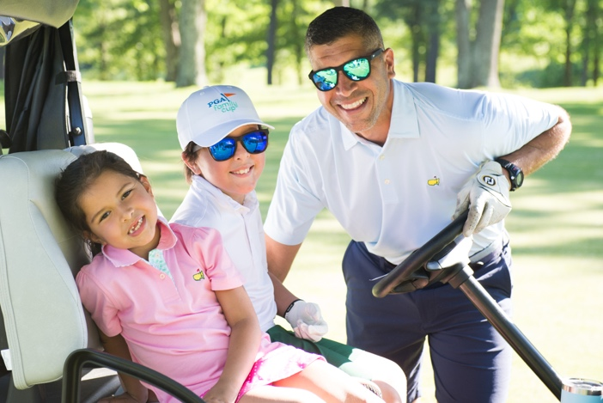





Don’t miss out on the opportunity to bring your family together and have a blast while creating lifelong memories on the golf course! Experience family time in a fun, new and meaningful way.

If you have any questions, please contact Name, Title at Facility, at phone number or email.

