LPGA*USGA Girls Golf Energize Experience Day presented by Zinus
Lesson Plan
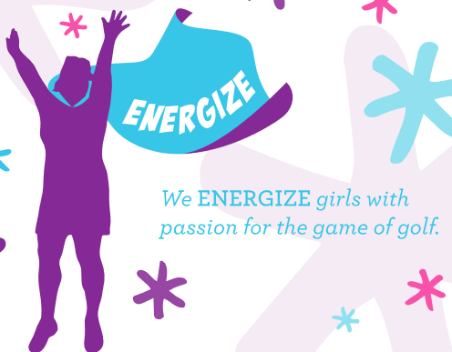

- Chipping Station: Zinus Activity
  - Introduce / Reinforce the fundamentals of aim during chip shots, while allowing the girls to use their creativity and engage with one another as a team.
  - Materials Needed – 5 cones (or other markers if cones are being used in putting), Printed Zinus images from Tool Kit for targets, cardboard or something sturdy to tape/glue the targets to.
  - Set Up:
    - Set the targets in a random structure on the chipping area
    - Set up 5 hitting stations marked by cones (or other markers) –spaced out for safety
  - Activity
    - Have the girls aim at the targets and try to hit / knock them down
    - Girls should take 3-5 shots and then rotate for the next group
    - Once all girls have had a chance to hit, have them put their clubs down and go reset the targets in a new structure – focus on where they are aiming in efforts to hit the targets.
  - Example Below: You can get creative with what to attach the targets to, below range baskets are used but alignment sticks, cardboard and other materials you have will work!
