LPGA*USGA Girls Golf Energize Experience Day presented by Zinus
Lesson Plan
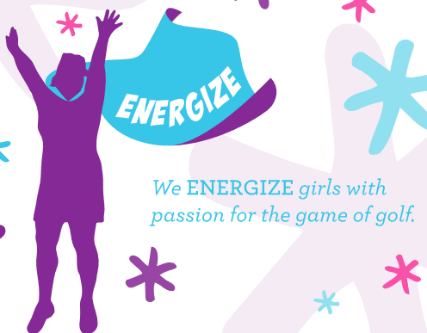

- Full Swing Station: Full Swing Fundamentals
  - Set Up
    - Use markers or cones to set up 5-6 stations on the driving range, define safety zones for the girls not hitting – survey tape, hula hoops are good options.
  - Activity:
    - Start a discussion with the girls about what they think goes into a golf swing. What parts and pieces (fundamentals) do we put into a good swing? Have one or two girls demonstrate some of the parts. Set up, tempo, footwork, posture, balanced finish, Y to L position.
    - Divide the girls into teams (no more than four per team)- Assign Players 1, 2, 3 and 4. Player 1 will be the golfer. Players 2, 3 and 4 will observe from safety zone.
    - Designate a fundamental for each non-swinging player to watch for
      - Ex. Player 2 watches for set up, Player 3 watches for Y to L position, Player 4 watches for balanced finish / TV pose.
    - After each swing, the non-swinging players will note if Player 1 successfully executed the fundamental. You can have paper to record or just open discussion. Do this for each player. And then rotate
    - For added fun, use water balloons with this activity! Bunch of balloons is a great way to blow up multiple water balloons at once. Can be found on Amazon, Walgreen, CVS

