LPGA*USGA Girls Golf Energize Experience Day presented by Zinus
Lesson Plan
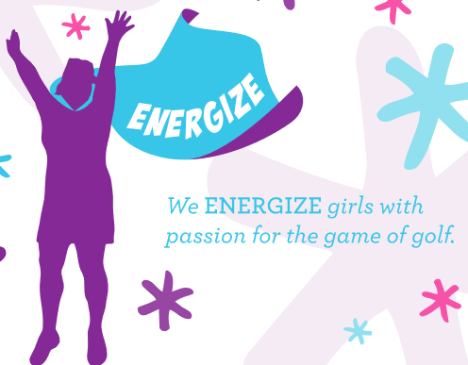

Icebreaker Game
“What does “Energize” mean – Instructors to explain what Energize means, why it is important. You will be provided an “Energize” word search for each girl to complete. Give them 5-7 minutes to complete.
Once the girls have completed the Energize Word Search, have the girls write down on the other side of the word search what “Energizes” means to them or what they learned about Energize. Depending on time, have the girls introduce themselves and share what they wrote down. If you have a big group, have a few girls volunteer to share.

Goal Setting Activity – To kick things off
Goal – To encourage goal setting and inspire each of the girls to take action on what they want and how they see themselves moving into the future. This activity will also help the girls increase their self-awareness.
- Depending on the number of girls at your program, split them up if needed into smaller groups (try to get groups of 4-5 girls with instructor).
- Ask the group to describe goal setting and what it means to them. If younger girls, you may need to explain goal setting and make sure they understand before moving forward with activity. Promote with other questions like:
  - How do you go about setting goals?
  - How do you go about achieving goals?
  - What steps can you take to reach your goals?
- Give them a few minutes to discuss with each other some of their goals, brainstorm and share. These goals may pertain to golf, life, family, school, career, relationships – anything.
- After this discussion period, give each of the girls a pen and paper. Have each girl find a comfortable spot that allows her to have her own personal space.
- Reflecting on the group discussion, have each girl write a letter to herself. She can write about future goals, steps she will take to reach them, as well as beliefs about herself right now and how she wants to be in the future.
- When they are finished writing, have them place the letter in an envelope and address it to themselves. Collect the letters from the girls.

