LPGA*USGA Girls Golf Energize Experience Day presented by Zinus
Lesson Plan
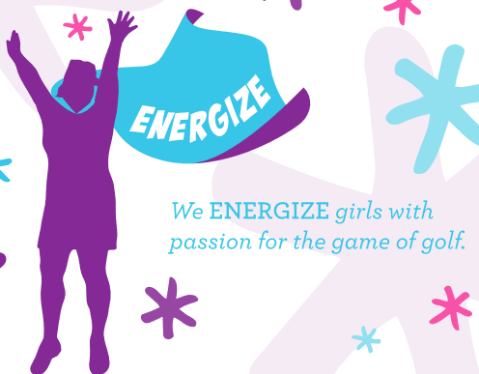
Initiative
As a host of the Girls Golf Experience presented by Zinus, you will have the great opportunity to grow your membership and engage your members in a fun and engaging Energize themed clinic. Girls will get to experience golf through putting, chipping, full swing and also wind down with a fun, creative craft.
Best Practices:
- Provide participants with nametags before you begin (name tag template: https://lpga.box.com/v/nametags)
- Before you start, remember to explain the importance of safety. Instruct the girls not to walk or stand close to someone who is going to be swinging a club, maintain social distancing and overall healthy habits. `
- Set up a “hydration station” with water and/or sports beverages and a few healthy snacks
- Before beginning the Experience, discuss the importance of stretching before playing golf or any physical activity.
- Be sure to have one instructor or volunteer for every 4 participants
- At the end of the Experience, invite the girls to share their thoughts and funny stories from the day with the group
#Girls Golf Photo
For added fun during your Girls Golf Experience, create an area around your Zinus Poster provided in your kit to have the girls stand around and take a photo as a group – making sure to incorporate the logo. For even more fun, have all the girls hold up a peace sign for the picture. Have all of your girls sign the poster for a special keepsake. Encourage participants to share their photos on social media using the hashtag #lpgausgagirlsgolf, #girlsgolf
**We ask that Site Directors collect plenty photos and video of the Energize clinic to share on social media and to share with our partner Zinus. For added support on this, designate an e-Leader, volunteer, or parent to be the photographer and get lots of great footage of the day!

Icebreaker Game
“What does “Energize” mean – Instructors to explain what Energize means, why it is important. You will be provided an “Energize” word search for each girl to complete. Give them 5-7 minutes to complete.
Once the girls have completed the Energize Word Search, have the girls write down on the other side of the word search what “Energizes” means to them or what they learned about Energize. Depending on time, have the girls introduce themselves and share what they wrote down. If you have a big group, have a few girls volunteer to share.

Goal Setting Activity – To kick things off
Goal – To encourage goal setting and inspire each of the girls to take action on what they want and how they see themselves moving into the future. This activity will also help the girls increase their self-awareness.
- Depending on the number of girls at your program, split them up if needed into smaller groups (try to get groups of 4-5 girls with instructor).
- Ask the group to describe goal setting and what it means to them. If younger girls, you may need to explain goal setting and make sure they understand before moving forward with activity. Promote with other questions like:
  - How do you go about setting goals?
  - How do you go about achieving goals?
  - What steps can you take to reach your goals?
- Give them a few minutes to discuss with each other some of their goals, brainstorm and share. These goals may pertain to golf, life, family, school, career, relationships – anything.
- After this discussion period, give each of the girls a pen and paper. Have each girl find a comfortable spot that allows her to have her own personal space.
- Reflecting on the group discussion, have each girl write a letter to herself. She can write about future goals, steps she will take to reach them, as well as beliefs about herself right now and how she wants to be in the future.
- When they are finished writing, have them place the letter in an envelope and address it to themselves. Collect the letters from the girls.

“Ready, Set… Golf!” Clinic
Set-up: Stations for putting, chipping, full swing, and pitching (optional). Encourage girls to bring their own clubs and have loaner clubs for guests, as well.
- Activity: Each station will be roughly 20 minutes long with 5-minute rotations. Instructor will explain the fundamentals of the stroke for that station including set-up. See station ideas below:

- Putting Station: Distance Control activity
  - Set Up
    - Use the cones provided in the kit and set them up in a vertical line about 3 feet from each other.
  - Activity:
    - Designate a starting point about 5 feet from the first cone. Ask the girls to name places that are close and places that are far away. Can use examples of cities in the US or different countries or relate it to places in your hometown that they know. (ex. Florida to New York, USA to Australia, Georgia to Alabama)
    - Designate each cone as a “place”. Have the girls partner up. One girl will putt while the other girl stands back and calls out which place to try and putt to. Have the girls take 3-5 putts each to try and get close to each place.

  - 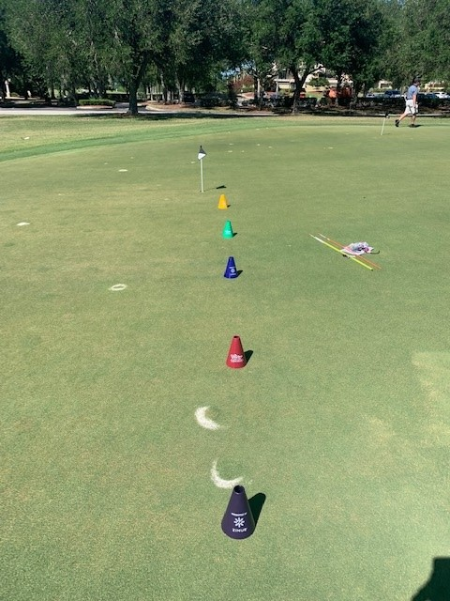

- Chipping Station: Zinus Activity
  - Introduce / Reinforce the fundamentals of aim during chip shots, while allowing the girls to use their creativity and engage with one another as a team.
  - Materials Needed – 5 cones (or other markers if cones are being used in putting), Printed Zinus images from Tool Kit for targets, cardboard or something sturdy to tape/glue the targets to.
  - Set Up:
    - Set the targets in a random structure on the chipping area
    - Set up 5 hitting stations marked by cones (or other markers) –spaced out for safety
  - Activity
    - Have the girls aim at the targets and try to hit / knock them down
    - Girls should take 3-5 shots and then rotate for the next group
    - Once all girls have had a chance to hit, have them put their clubs down and go reset the targets in a new structure – focus on where they are aiming in efforts to hit the targets.
  - Example Below: You can get creative with what to attach the targets to, below range baskets are used but alignment sticks, cardboard and other materials you have will work!
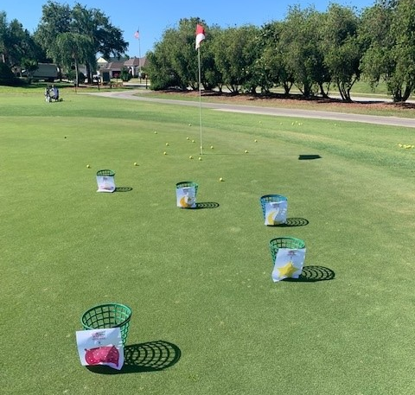
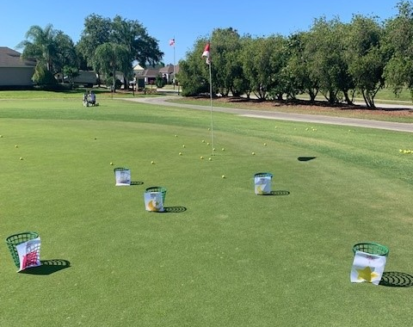
- Full Swing Station: Full Swing Fundamentals
  - Set Up
    - Use markers or cones to set up 5-6 stations on the driving range, define safety zones for the girls not hitting – survey tape, hula hoops are good options.
  - Activity:
    - Start a discussion with the girls about what they think goes into a golf swing. What parts and pieces (fundamentals) do we put into a good swing? Have one or two girls demonstrate some of the parts. Set up, tempo, footwork, posture, balanced finish, Y to L position.
    - Divide the girls into teams (no more than four per team)- Assign Players 1, 2, 3 and 4. Player 1 will be the golfer. Players 2, 3 and 4 will observe from safety zone.
    - Designate a fundamental for each non-swinging player to watch for
      - Ex. Player 2 watches for set up, Player 3 watches for Y to L position, Player 4 watches for balanced finish / TV pose.
    - After each swing, the non-swinging players will note if Player 1 successfully executed the fundamental. You can have paper to record or just open discussion. Do this for each player. And then rotate
    - For added fun, use water balloons with this activity! Bunch of balloons is a great way to blow up multiple water balloons at once. Can be found on Amazon, Walgreen, CVS

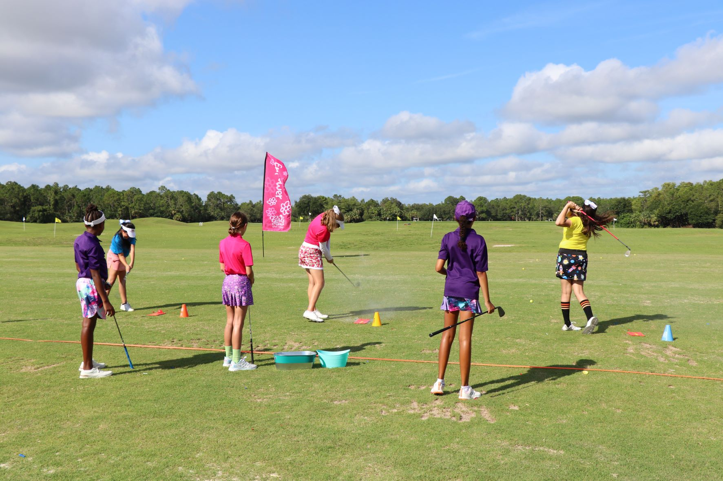

- ***Include a Know Before You Go session at the beginning to cover safety rules and etiquette.***
- **For incorporating all 5 E’s as stations – include a craft/snack station and exercise station. Example: Empower – Full Swing, Energize- Chipping, Enrich – Putting, Engage- craft and snack, and Exercise – Relay Race / Hula Hooping

Design Your Own Golf Hole – Craft
Set-up: Supplies needed –Card stock white paper (can be 81/2x 11), scissors, glue sticks, golf magazines, construction paper. Make sure to have 6 or 8 ft. tables set up near the golf stations that provides enough room girls to create the hole. If you have a big group, you will want to do these stations in stages.
Activity: Each girl will get the supplies listed above and will be asked to use their imagination to design their own golf hole. They can use the magazines (If available) and the construction paper to cut out fairways, greens, bunkers, water, hazards, etc. Give them ideas on deciding if they want to design a Par 3, Par 4 or Par 5 (or maybe they want to make up their own Par) and how hard they want the hole to be. Also encourage them to name the hole and pick what state/location they would design it in.
Have the girls or a few girls share their designs to the group.

Energize Kit Items:
- One (1) Purple drawstring bag for host
- Five (5) colored Girls Golf Cones – 5 E Colors for host
- One (1) Energize Poster for host
- Energize Word Search – one per clinic participant
- Energize 5 pack of crayons – one per clinic participant
- Experience Day logoed ballmaker/poker chip – one per clinic participant

