LPGA*USGA Girls Golf Energize Experience Day presented by Zinus
Lesson Plan


- Putting Station: Distance Control activity
  - Set Up
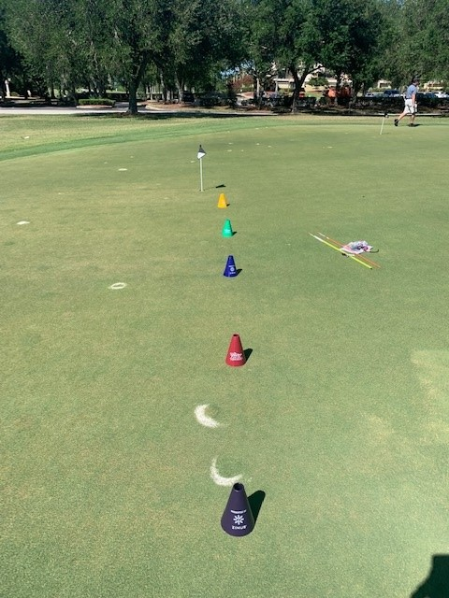
    - Use the cones provided in the kit and set them up in a vertical line about 3 feet from each other.
  - Activity:
    - Designate a starting point about 5 feet from the first cone. Ask the girls to name places that are close and places that are far away. Can use examples of cities in the US or different countries or relate it to places in your hometown that they know. (ex. Florida to New York, USA to Australia, Georgia to Alabama)
    - Designate each cone as a “place”. Have the girls partner up. One girl will putt while the other girl stands back and calls out which place to try and putt to. Have the girls take 3-5 putts each to try and get close to each place.

